Capstone Project 1: Statistical Analysis

By Laura Gascue

## Introduction

Since 2014, with the Affordable Care Act (ACA), individuals without access to health care insurance through employment, can purchase in the Health Insurance Marketplace through state created exchanges. The system was created to define a set of minimum coverage standards at affordable cost, aiming to widely expand access to health insurance. This policy has been used as a political campaign banner by both parties, with Democrats supporting the policy and Republicans trying to eliminate it. In this note we look at how State Governor's political party correlates with the number of health care options an individual faces in the individual health insurance market. We look at options using two different measures: the number of plans an individual faces when choosing health coverage through the exchanges, and the number of issuers (insurance companies) offering coverage.

The analysis is limited to the health insurance plans being offered in the US in 2018 through the federally facilitated exchanges. There are 39 states under the federal program. An individual will have access to the plans offered in the area they live (offered in their county). We compute the number of plans being offered in each FIPS county code on those states and use it as a measure of the level of competition in that market.

## States Political Color and Health Plans Offered

The Centers for Medicare & Medicaid Services uploads health insurance plan information on all federally facilitated exchanges through the [healthcare.gov](https://www.healthcare.gov/) website. We use the data corresponding to plans available in 2018. The database cover 39 states: AK, AL, FL, AR, AZ, DE, GA, IL, MI, HI, MO, IA, IN, MS, KS, KY, LA, ME, MT, PA, ND, NJ, NE, NM, NH, NC, OR, WI, NV, OH, OK, SD, SC, VA, TX, TN, UT, WV, WY. The number of total distinct plans offered is 2,722.

We identify the governor's political party at the beginning of 2018 for each of the states with federally facilitated exchanges under the ACA. There are 9 states under a democratic governor, 29 states under a republican governor, and one state with an independent governor. Note that the number of Democratic states opting to manage their own exchange and not included in this analysis, is proportionally larger than the number of Republican states choosing this option (7 Democratic states vs 4 Republican states). Since we have just one state with an independent governor, we leave this state out of the analysis.

Table 1 shows the distribution of number of issuers at the county level by state’s Governor political affiliation. The large majority of the counties offer health insurance through no more than four companies. States with a Republican governor tend to have fewer issuers with 87% of counties presenting just one or two issuers but a longer right tail. In contrast, counties under a Democratic governor presenting one or two issuers account for 64.5% of all counties. The differences in the distribution of number of plans is less clear (see Figure 1) but still shows a more concentrated distribution in Democratic counties, but slightly shifted to the right respect to the distribution in Republican counties.

Table 1 – Federally Regulated States

|  |  |  |  |
| --- | --- | --- | --- |
| Number of Issuers | Democratic (%) | Republican (%) | Independent (%) |
| 1 | 46.1% | 57.8% | 100.0% |
| 2 | 18.4% | 29.2% | n/a |
| 3 | 30.4% | 4.1% | n/a |
| 4 | 4.5% | 6.8% | n/a |
| 5 | 0.6% | 1.7% | n/a |
| 6 | n/a | 0.2% | n/a |
| 7 | n/a | 0.1% | n/a |

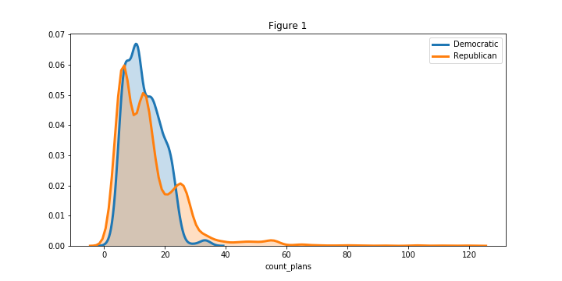

## How Number of Plans Offered Changes Depending on Governor’s Party Affiliation?

We are going to test the hypothesis that the expected number of plans in states with a Democratic Governor ($μ_{D}$) is the same as the expected number of plans in states with a Republican Governor ($μ_{R}$).

H0: $μ_{D}= μ_{R}$

We use a bootstrap approach for this test. Under the null hypothesis the expected value of both means is the same, but their variance is not necessary the same. To generate bootstrap replicates we shift both distributions so their sample means are the same and we sample multiple times from it. We use $τ{=μ}_{D}- μ_{R}$ to test the hypothesis.

We take 10,000 samples from the shifted distribution of plans of the same size as the original data, and for each simulation we compute the observed $τ$ as the difference between both averages. We use the obtained distribution to compute the p-value of the actual observed difference (-1.71). Under the null hypothesis, observing a difference of -1.71 is highly unusual with a p-value < 0.001. Given that a state opts to have their individual health insurance exchange facilitated by the Federal Government, States with Republican governors tend to have more plan options for individuals.

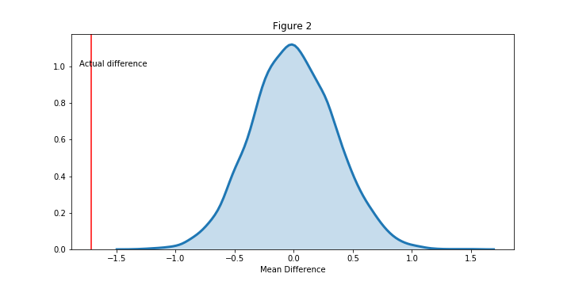

There is a significant difference between counties under a Democratic and a Republican governor in the number of health plan options and individual faces when purchasing insurance through individual market exchanges when they are managed at the federal level. The number of options is higher for Republican areas though the size of the difference is small (1.7 in a market with on average about 14 different plans). However, the expected number of insurance companies operating in those counties is lower in Republican areas.